**IDENTITY COLUMN**

Auto-increment allows a unique number to be generated automatically when a new record is inserted into a table. Often this is the primary key field that we would like to be created automatically every time a new record is inserted.

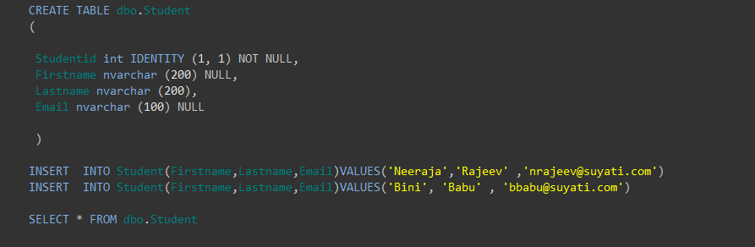

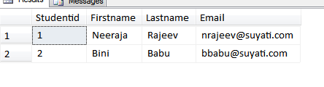

Here the column Studentid is defined as the identity column. In the Identity column, the value of the first argument defined the initial value for this column and the value of the second argument defined the value used to add in the last value of this column for getting the next value.

Only one Identity column is possible for a table. In case of truncate command on a table, the identity column value is reset to 0.

To set the Identity column property on, the following command is used:

**SET IDENTITY_INSERT Tablename On**

To set the Identity column property off, the following command is used:

**SET IDENTITY_INSERT Tablename Off**

**Reseed the Identity field**

You can also reseed the identity field value. By doing so identity field values will start with a new defined value

**DBCC checkident (Tablename, RESEED, Value)**

Suppose you want to reseed the Student table ID field from 3 then the new records will be inserted with ID 4, 5, 6 and so on.

Checking identity information: current identity value '4'.

DBCC execution completed. If DBCC printed error messages, contact your system administrator.

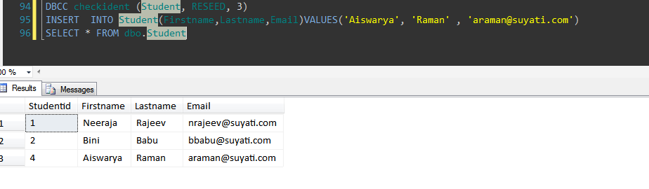

These are the Transact-SQL functions in SQL Server that can be used to retrieve identity column values. To get the ID of the newly inserted record there are three methods available.

**What SCOPE_IDENTITY is**

SCOPE_IDENTITY is:

1. SCOPE_IDENTITY returns the last IDENTITY value inserted into an IDENTITY column in the same scope.
2. SCOPE_IDENTITY returns the last identity value generated for any table in the current session and the current scope.
3. A scope is a module; a Stored Procedure, trigger, function, or batch.
4. Thus, two statements are in the same scope if they are in the same Stored Procedure, function, or batch.
5. The SCOPE_IDENTITY() function will return the NULL value if the function is invoked before any insert statements into an identity column occur in the scope.

**What IDENT_CURRENT is**

IDENT_CURRENT is:

1. IDENT_CURRENT returns the last identity value generated for a specific table in any session and any scope.
2. IDENT_CURRENT is not limited by scope and session; it is limited to a specified table.

**What @@IDENTITY is**

@@IDENTITY is:

1. @@IDENTITY returns the last identity value generated for any table in the current session, across all scopes.
2. If the statement did not affect any tables with identity columns, @@IDENTITY returns NULL.
3. If multiple rows are inserted, generating multiple identity values, @@IDENTITY returns the last identity value generated.

SCOPE_IDENTITY and @@IDENTITY will return the last identity values generated in any table in the current session. However, SCOPE_IDENTITY returns values inserted only within the current scope; @@IDENTITY is not limited to a specific scope.